Zebrafish Anxiety Protocol – Tall Tanks vs Short Tanks

**Experimental design**

Each individual will experience the anxiety assay in each tank twice (a total of 4 experiments which must be a minimum 2 days apart). For each experiment, all fish are to be run in a single day. Order of tanks containing fish to use must be pseudorandomized to account for day of experiments as well as time of day. Individuals from within the tank must be selected at random to run in the trials. Experimental design can look as such (numbers indicate tank):

|  |  |  |  |  |
| --- | --- | --- | --- | --- |
| **TOD** | **Experiment 1** | **Experiment 2** | **Experiment 3** | **Experiment 4** |
| **Morning** | 1 | 8 | 5 | 4 |
| **Morning** | 2 | 7 | 6 | 3 |
| **Noon** | 3 | 6 | 7 | 2 |
| **Noon** | 4 | 5 | 8 | 1 |
| **Noon** | 5 | 4 | 1 | 8 |
| **Afternoon** | 6 | 3 | 2 | 7 |
| **Afternoon** | 7 | 2 | 3 | 6 |
| **Afternoon** | 8 | 1 | 4 | 5 |
|  | Mon | Wed | Fri | Mon |
|  |  |  |  |  |
| ***Tank types:*** |  |  |  |  |
|  | Short |  |  |  |
|  | Tall |  |  |  |

Trial lists holding information about the trial are key. They can look as such (being filled in as fish are selected at random; or pre-prepared):



**Materials, setup and procedure**

* Holding tanks typically used in zebrafish anxiety assays (trapezoidal; width 11cm, height 17.5cm, length at top 28cm; standardized mark at 15cm ensures water volume is 3.4L; see Figure 1)
* Custom-designed tall tanks with custom dimensions to increase depth (width 7cm, height 152cm, length 10.5cm; standardized mark at 46cm ensures water volume is 3.4L; see Figure 1)
* Temporary holding tanks with internal plastic strainer (14cm x 9cm x 9cm; 1.13L; for easy transferal of fish; see Figure 2)
* Video camera x2 (OPTIONAL: with settings configured for use with a wireless tablet)
* Corflute®
* Makeshift platform (at least 25-30 cm in height; and wide enough to place two trapezoidal tanks on) x2

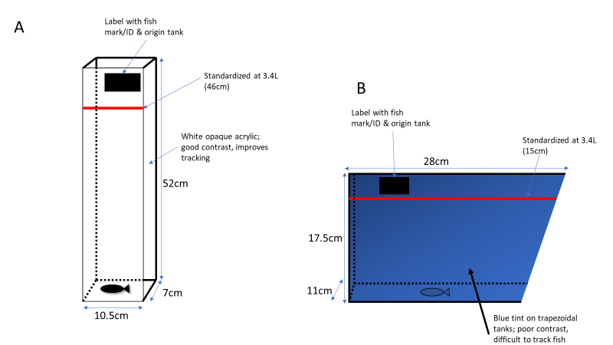

Figure 1) Tanks used in zebrafish anxiety experiments; A) Tall novel tank and B) traditional trapezoidal holding tank

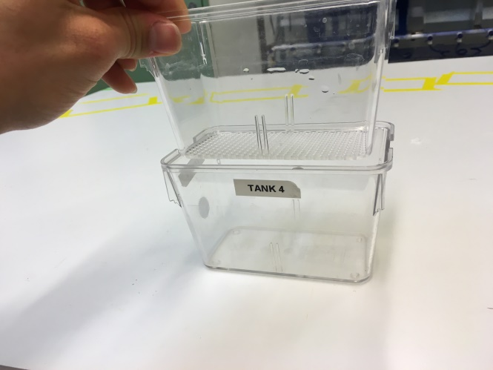

Figure 2) Temporary holding tank with internal strainer

**Step 1)** Arena setup

*Tall tanks*

When utilizing tall tanks, set up 6 tanks to run 6 fish per trial. All 6 tanks will be set up side by side and facing the camera (see Figure 3). Once set up, their positioning must be marked with a marker so as to ensure high accuracy of re-positioning once they are to be moved for changing of water.

Corflute is used to block all sides of the main arena except the front portion where the camera will be placed (see Figure 3); this ensures that fish are not disturbed during trials. Tape is used to secure the corflute, with the back portion being removable to allow placing fish into the testing tanks

NOTE: To make the trial higher throughput for tall tanks, one can employ the use of two cameras to film 8 tall tanks as opposed to 6 (4 per camera).

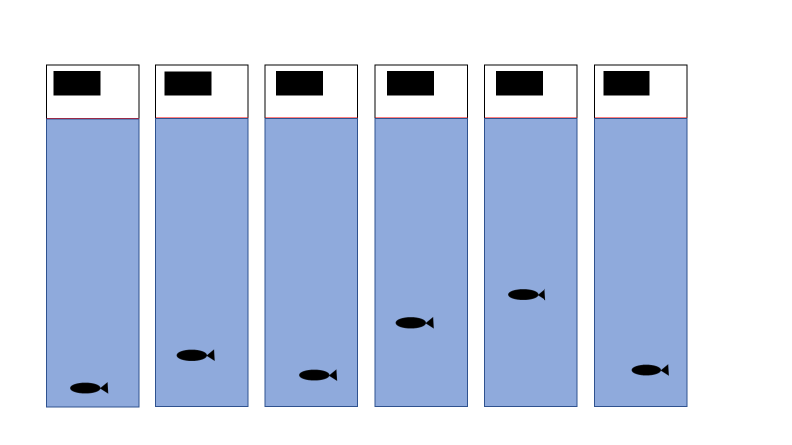

Figure 3)

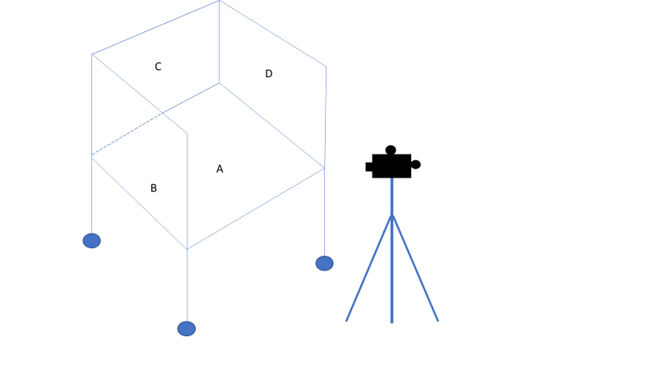

Figure 4) A) Main platform where testing tanks will be placed and B,C,D) sides of the arena where corflute will be placed to ensure fish are not disturbed during trials. The back of the arena (C) will be removable

*Trapezoidal tanks*

When utilizing trapezoidal tanks, one can set up a maximum of 8 tanks to run 8 fish per trial. Unlike the tall tanks, the setup for the trapezoidal tanks requires the use of 2 cameras (see Figure 5). In order to fit 4 tanks in the frame of one camera, use a custom platform (raised approximately 25cm) to place two tanks on top (place corflute was between the tanks on the raised platform to block each tanks view of other tank). The other two tanks will be placed on the original platform beneath and slightly closer to the camera (corflute was also placed between the tanks). This would result in an even image in terms of tank positions (see Figure 6). To be able to use 8 tanks, this same setup must be used on the other half of the main platform (corflute was placed between both setups; see Figure 5). Once set up, their positioning must be marked with a marker so as to ensure high accuracy of re-positioning once they are to be moved for changing of water. NOTE: Since two sides of the platform was used, corflute was only placed on the sides where the camera wasn’t placed.

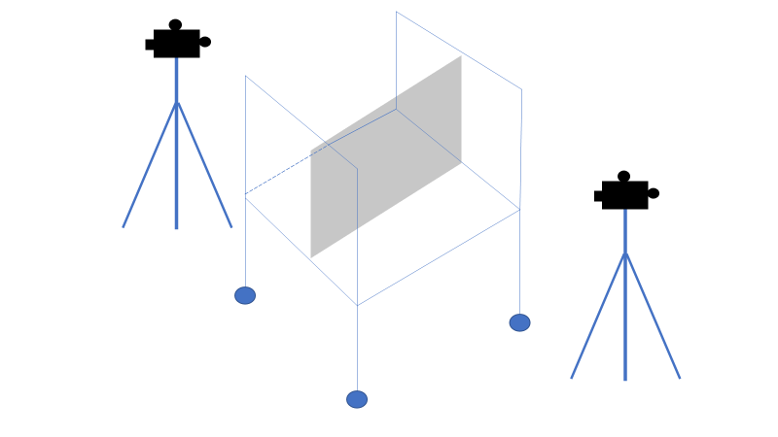

Figure 5) Basic setup of main platform when using two cameras as opposed to one; with two sides blocked with corflute, and a camera on either side of the platform. Corflute is also placed in the middle of the platform so as to block either half of the arena from the trials

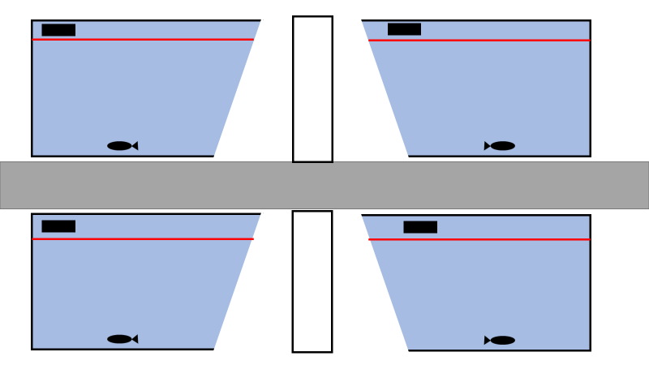

Figure 6) Setup of 4 trapezoidal tanks per camera

**Step 2)** Camera setup

A camera will be attached to a tripod and placed 1 meter from the arena set up to ensure all tanks are captured. Care must be taken with the positioning of the camera so that all tanks are in clear view and the entirety of the tank can be seen so there are no blind spots when recording. Ensure all lights are on and that the setup is clear and not dim (look at the camera and ensure tanks do not look yellow or dark with shadows). Further it is important that the camera not move, as this will make Ethovision work difficult.

**Step 3)** Zebrafish setup

Zebrafish required for the experiment will be extracted from their home tanks with a net and placed into individual holding tanks. These are small tanks fitted with a plastic strainer in the same form of the tank so as to remove the fish without using a net (see Figure 2). They are 14cmx9cmx9cm and approximately have a capacity of 1.13L. There will be a total of 6 individual holding tanks when using tall testing tanks and 8 individual holding tanks when using trapezoidal testing tanks. All temporary holding tanks

**Step 4)**Experimental procedure

Fish will be recorded for a total time of 8 minutes (a single trial). Acquisition of data will begin after 40 seconds as this will allow experimenters adequate time to place fish in holding tanks and remove themselves and equipment from the frame (as well as allowing the camera contrast to settle as lighting will change subtly). The testing area should be devoid of sudden and rapid movements, noise or vibrations during trials. Care must also be taken to ensure nothing gets in the way of the camera. Record any events that may affect the outcome of the trial or experimental settings during data acquisition (i.e as these events may warrant the eventual exclusion from the final dataset or instigate a repeat; it will also help with issues encountered during acquisition or any strange behavioral results). Commonly encountered events include fish jumping from the net upon entry into experimental tanks, the camera or tank being moved, or there are incorrect/misplaced labels.

While an active trial is on-going, prepare the next batch of fish individuals from their group tanks to their pre-trial temporary holding tanks. Also prepare their corresponding labels taking note of fish marking and individual/group ID.

After recording, carefully remove fish from the test tank using hand nets, returning them to another temporary container (so as not to mix tested and untested individuals). Remove old labels from the experimental tanks and add new labels. Continue forth with the remainder of the trials.

After five trials, the water must be changed to account for water temperature changes as well as stress hormones that may be present. Change water accordingly and make sure to place tanks back in line with the markings of their earlier positions. Take great care in ensuring the camera is not touched.